Calculating Family Expenses Using Service Now

**Team Id:**

Team Members:

Team Leader:Priya M

Team Member 1:Shanthi G

Team Member 2:Anusha R

Team Member 3:Hemavathi K

**Problem Statement**

In a project of managing family expenses is often challenging due to the lack of a centralization system for tracking income,excpenses, and savings.Families typically rely on manual methods such as spreadsheet,paper records,or multiple apps,which can lead to errors,duplication,and difficulty in analyzing financial patterns.

**Objective**

**Simplify Expense Tracking**- provide a centralization system for recording and categorizing all family expenses

**Improve Financial Awarness-**offer real-time dashboards and reports to give clear insights into spending patterns

**Enhance Budget Planning-**support better financial planning by identify high-spending categories and opportunities

**Skills: Update,Table,Relationship,** Configuring Related List ,Business Rules,Configure The Relationship

## 

**TASK INITIATION**

## Milestone 1:Update

**Activity 1:Update Set**

1.Open Service now

2.Go to All>>search for Local Update Set>Click on New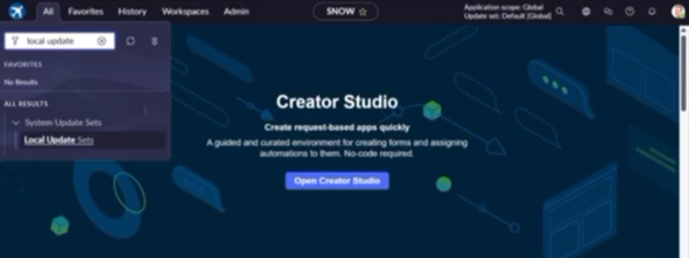

3.Enter the Details as:

Name:Family Expenses

4.And then click on Submit and make current

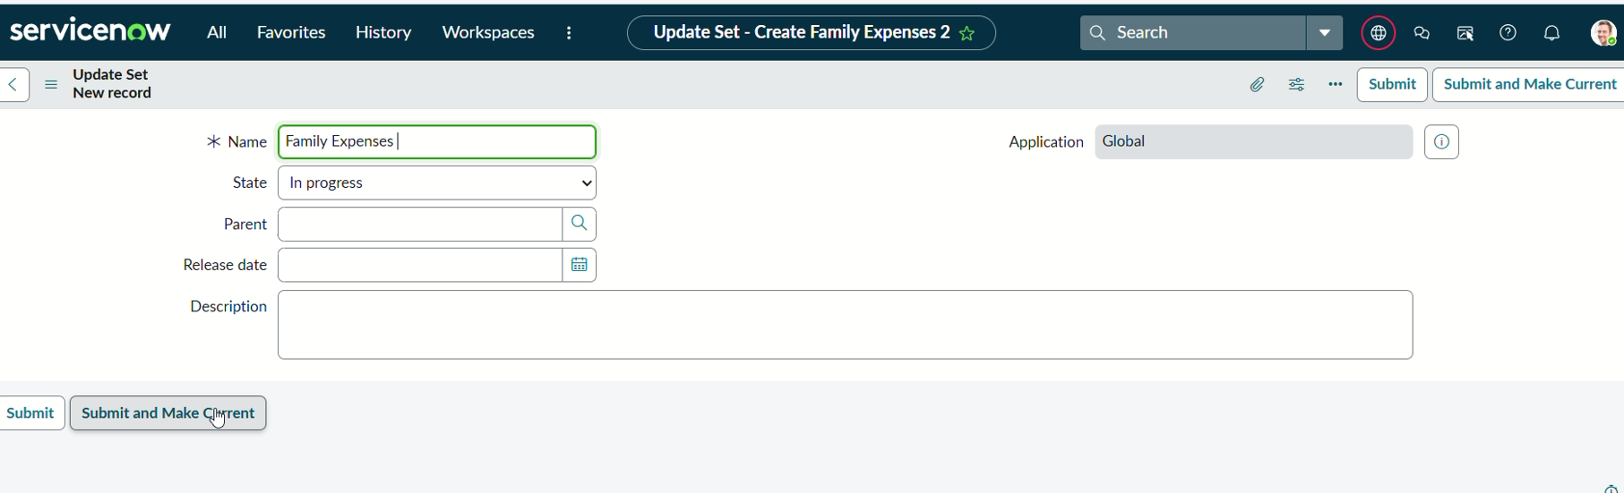

## **Milestone 2:Table**

Activity 1:Expenses Table

1.Open Service now

2.Go to all>search for Tables>Click on New

3.Enter the Details:

Label:Family Expenses

Name:Auto-Populated

New menu name:Family Expenditure

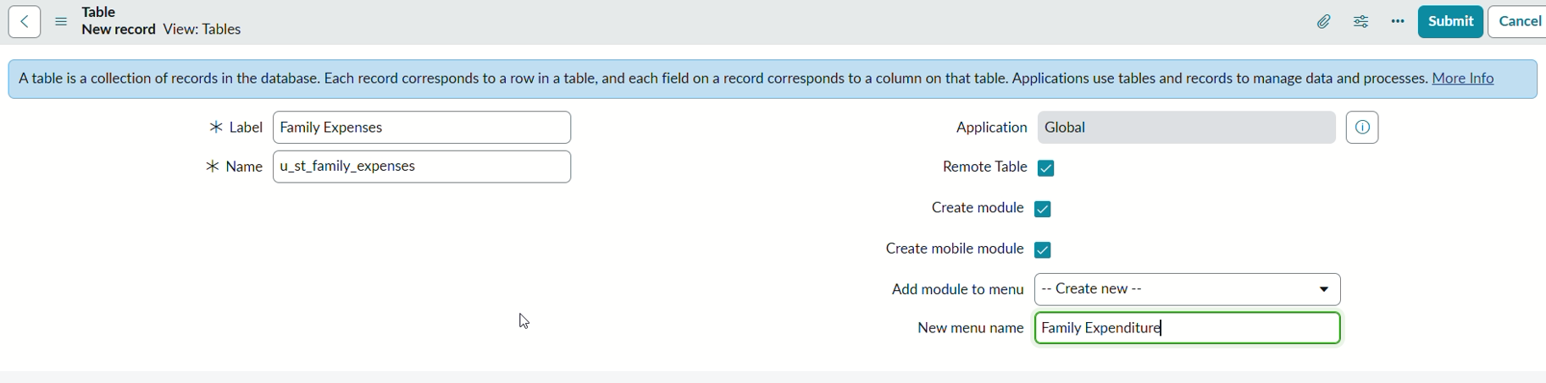

4.Click on save

Activity 2: Columns(Fields)

1.Open Service now

2.Near Columns Doubl;e Click near insert a new row

Give the details as:

Column label:Number

Type:String

3.Double click on insert a new row again

Give the details as:

Column label:Date

Type:Date

4.Double click on insert a new row again

Give the details as:

Column label:Amount

Type:Integer

5 .Double click on insert a new row again

Give the details as:

Column label:Expense Details

Type:String

Max length:800

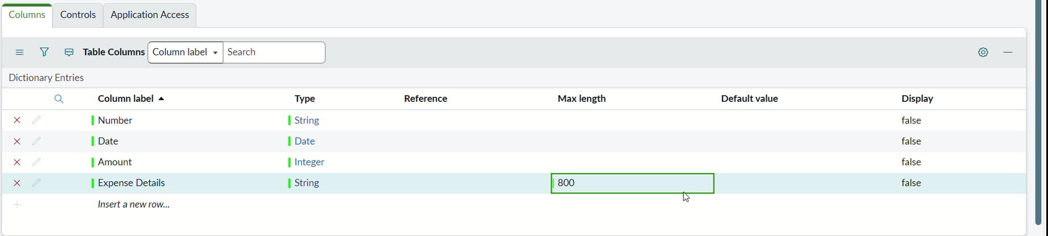

6.Click on save

Activity 3:Auto-Number

1.Open Service now

2.Double click on the Number field/Column

3.Go down and double click on Advanced view

4.In Default Value:

Use dynamic default:check the box

Dynamic default value:Get Next Padded Number

5.click on update

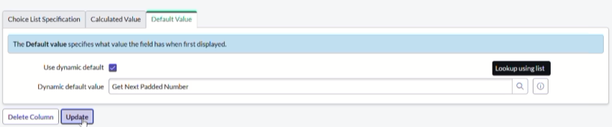

6.Go to all>>search for Number Maintenance>>select number maintenance

7.click on new

8.Enter the details:

Table:Family Expenses

Prefix:MFE

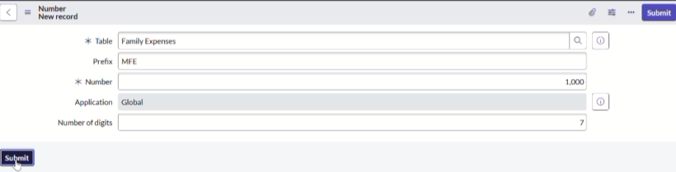

8.Click on Submit

Activity 4:Configure The Form

1.Open Service now

2.Go to all>>search for Family Expenses>>Open family Expenses

3.Click on new

4.Go to header and click there>>click on configure>>Select Form Design

5.Drag Drop the form as requirement

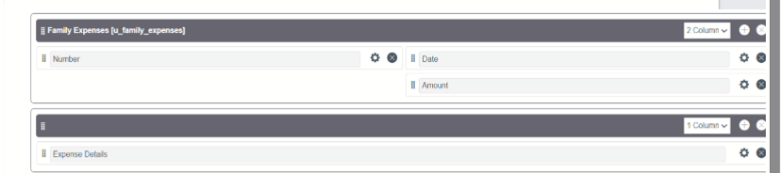

6.Make Number Read-Only Field by Clicking

7.Make Date,Amount Mandatory field by Clicking

8.Click on save

## Milestone 3:Table(Daily Expenses)

Activity 1:Daily Expenses Table

1. 1.Open Service now

2.Go to all>search for Tables>Click on New

3.Enter the Details:

Label:Daily Expenses

Name:Auto-Populated

Add Module to menu :Family Expenditure

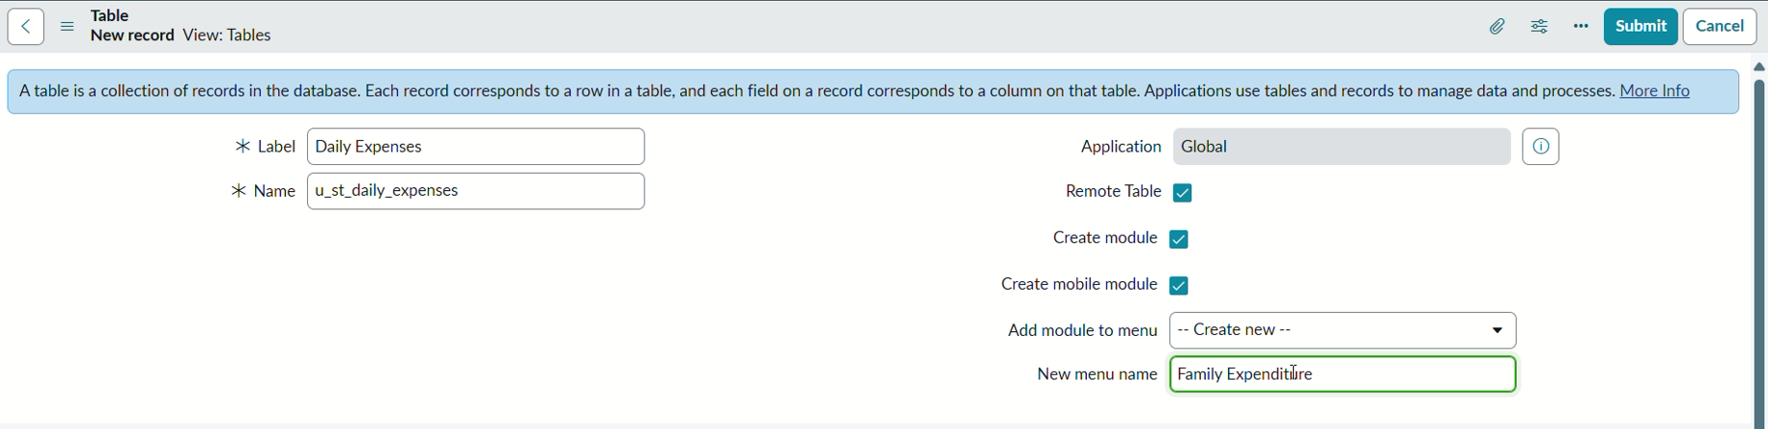

4.click on save

Activity 2:Columns(Fields)

1.Open Service now

2.Near Columns Doubl;e Click near insert a new row

Give the details as:

Column label:Number

Type:String

3.Double click on insert a new row again

Give the details as:

Column label:Date

Type:Date

4. Double click on insert a new row again

Column label:Amount

Type:Integer

5 .Double click on insert a new row again

Column label:Expense Details

Type:String

Max length:800

6.Double click on insert a new row again

Give the details as:

Column label:Comments

Type:String

Max length:800

6.Click on save

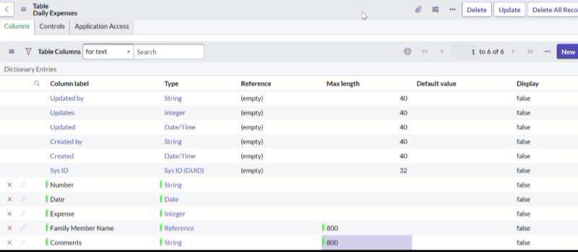

Activity 3:Auto-Number

1.Open Service now

2.Double click on the Number field/Column

3.Go down and double click on Advanced view

4.In Default Value:

Use dynamic default:check the box

Dynamic default value:Get Next Padded Number

5.click on update

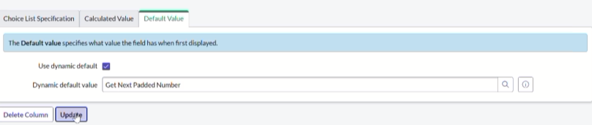

6.Go to all>>search for Number Maintenance>>select number maintenance

7.click on new

8.Enter the details:

Table:Daily Expenses

Prefix:DFE

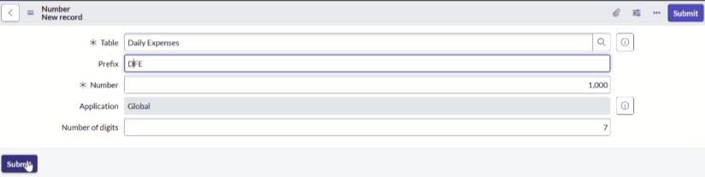

9.click on submit

Activity 4:Configure The Form

1.Open Service now

2.Go to all>>search for Daily Expenses>>Open Daily Expenses

3.Click on new

4.Go to header and click there>>click on configure>>Select Form Design

5.Drag Drop the form as requirement

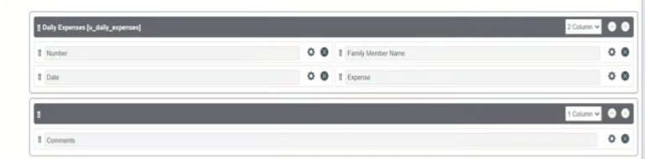

6.Make Number Read-Only Field by Clicking

7.Make Date,Family Member Name Mandatory field by Clicking

8.Click on save

## Milestone 4:Relationship

Activity 1:Family Expenses and Daily Expenses Tables

1.Open Service now

2.Go to all>>search for relationships>>open relationships

3.click on new

4.Enter the details:

Name:Daily Expenses

Applies to table:select Family Expenses

Daily Expenses:select Daily Expenses

5.click save

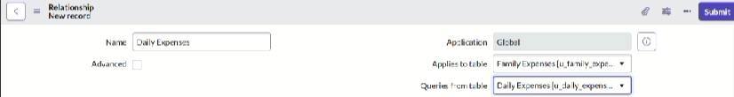

## Milestone 5:Configuring Related List

Activity 1:Configuring Related List On Family Expenses

1.open Service now

2. .Go to all>>search for Family Expenses>>Open FamilyExpenses

3.Click on new

4.Go to header and click there>>click on configure>>select Related Lists

5.Add Daily Expenses to selected area

6.click on save

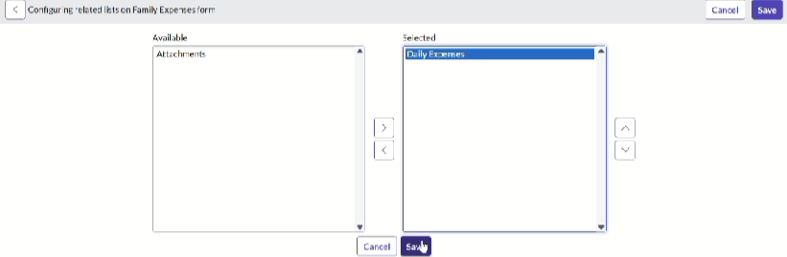

## Milestone 6:Business rules

Activity 1:Create Business Rules

1.Open Service Now

2.Go to all>>search for Business Rules

3.Under system definition select business rules then click new

4.Enter the Details:

Name:Family Expenses BR

Table:Select Daily Expenses

Check Advanced

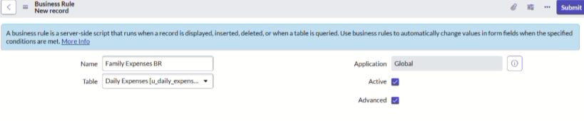

5.In when the run check insert and update

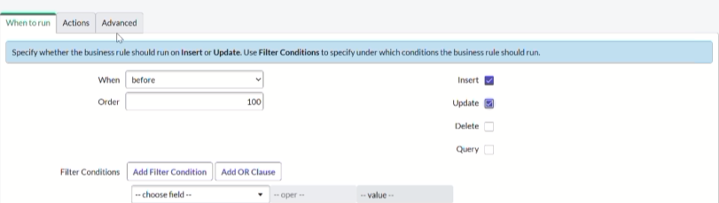

6.In Advance(we write the code)

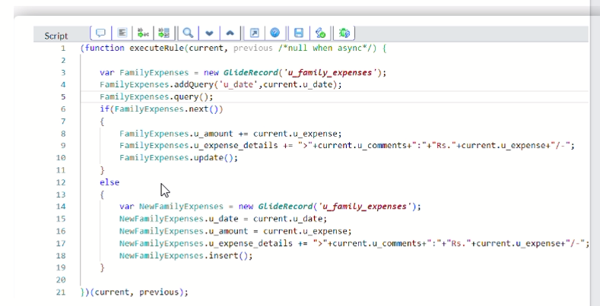

7.click on save

## Milestone 7:Configure The Relationship

Activity 1:Configure Relationship

1.Open Service now

2.Go to all>>search for relationships>>open relationships

3.In open Daily Expenses relationship

For Applies to table:select Family Expenses

In Query with:write the below Query

4.click on update

## 

## Conclusion

Using ServiceNow to calculate and track family expenses provides a structured,automated,and transparent approach to personal financial management.By leveraging ServiceNow’s workflow,reporting,and automation capabilities,families cac centralize their expense records,categorize spending,and generate real-time insights into their financial health